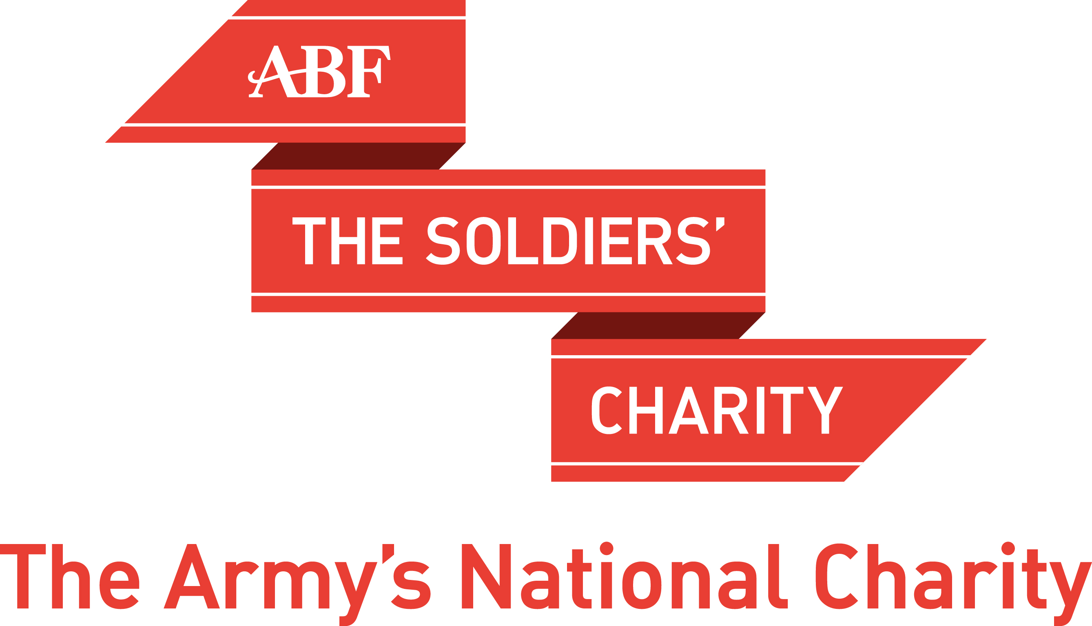

The Revision Cadet Challenge
Entry Submission Summary

Remember to take photos of your fundraising activity (action shots please, doing not standing! Minimum resolution 300dpi)

Detachment Details
Detachment Name/Location
Contact Details
Detachment Address
Detachment Postcode
Detachment Email Address
Detachment Point-of-Contact
Name
Tel/Mob No
Email Address
CO/OC Details
i.e. name, initials, Christian name known by, post nominals
Total Money Raised By Unit |  | £
Number Of Cadets In Unit

Please complete this form with a summary of your activities and return it to your local ABF The Soldiers’ Charity Regional Director, as listed below or at http://www.soldierscharity.org/about-us/our-work-in-the-regions/ for postal address details by COP 17 June 2021.

London: Tim Coles, london@soldierscharity.org
Scotland: Charles Dunphie, scotland@soldierscharity.org
North East: Barney Barnbrook, northeast@soldierscharity.org
North West: Phil Naylor, northwest@soldierscharity.org
East Midlands: Stu Wiles, eastmidlands@soldierscharity.org
East Anglia: Peter Harclerode, eastanglia@soldierscharity.org
South East: Will Tower, southeast@soldierscharity.org
South West: Peter Bates, southwest@soldierscharity.org
Wales: Pete Davies, wales@soldierscharity.org
West Midlands: Richard Hackett westmidlands@soldierscharity.org
Northern Ireland: David Forsey, ni@soldierscharity.org

Units stationed where there is no RD should return the form to:
Brigadier Colin Tadier at the address shown below or via email at ctadier@soldierscharity.org
ABF The Soldiers’ Charity
Mountbarrow House
620 Elizabeth Street
London SW1W 9RB
0207 901 8900

